Outline the objectives of the project and define the problem Draft copy

Problem – is this an objective or a summary?

* Talk about the overall reason of the report
* Describe some of the problem in the report

The overall objective of the report is to introduce the new design for the Call management Centre, for a major travel company. This new information system which includes the Call Management Centre (CMC) will help the flow rate of calls to help the relation management as it is essential for the performance for the sales in holiday packages with features such as inbound / outbound calls that would improve assistances to the relation management . These improvements if applied, it helps existing-customers or new customers and provide many features.

The problem arises when the current RM where segmenting customers information into different segment type such as postcodes and surname, thus this report will discuss the extensive methods that will be deployed to support many more information such as the age, gender, language to create a skill matcher which finds the connections between the customers and the RM.

The solution proposed in the report would feature several benefits with the new systems, some include recruitment as RM profiles can provide many useful information such as the overall profile and skill matrix to be lodged in the system with information gathering technique such as questionnaires. This will ensure that the RMs will produce better performance in selling and serving customers more efficiency and effective

.

Design Thinking Methodology

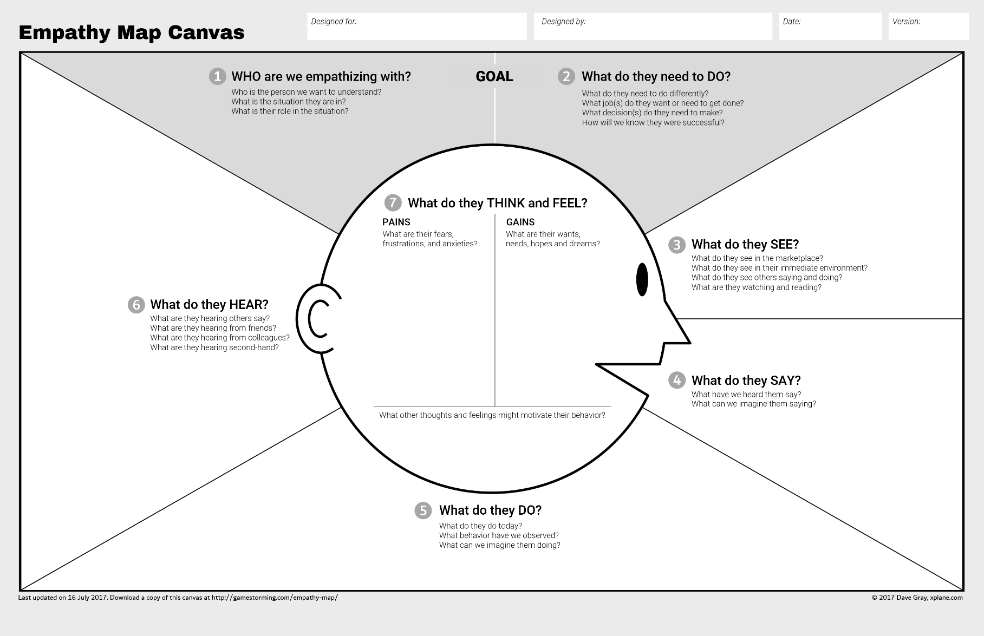Empathy – End customers? possible